# A Visionary Framework for AI-Driven Predictive and Real-Time Analytical Analysis of Aviation Anomalies, Incidents, and Accidents

**Abstract:** Aviation safety inquiry traditionally has been reactive, based on post-incident examination of data gathered from multiple stakeholders. It’s then processed by Human Factors. This study is seeking to enhance the process for analyzing aviation accidents while making the best use of people and time. It does this by creating an AI-driven, proactive safety process through an S-D-E-A-L cycle with a closed-loop MLOps process. The purpose of this framework is to speed up root cause analysis, anomaly detection, and simultaneous execution of corrective measures across operations. This study's solution combines narrative-based human factors categorization systems with multi-source operational data, including FDR data, CVR audio, ADS-B signals, external digital video, and maintenance logs. To all the parties involved—flight crew, maintenance, safety management staff, and operators—this integrated solution offers total, easily comprehensible real-time information. In addition, regular feedback with the operator's SMS results in the model being retrained continually to refine the risk prediction function and calibrate alerts. The architectural characteristics, deployment schedule, and promise of the suggested approach are discussed in this paper based on existing literature on aviation accident analysis as well as comparisons with conventional models. These observations decrease the time taken to analyze and resolve aviation accidents and provide inputs for future model development. The last objective of the research study is to formulate a new model that aligns with modern predictive maintenance practices and adheres to International Civil Aviation Organization safety standards, or ICAO. ARE WE NOT TALKING ABOUT FASTER CLEARER, AND LESS BIASED ACCIDENT INVESTIGATION, WITH PREDITIVE ISSUES BEING AN ADDED BONUS TO THE PROCESS?

**Keywords:** Explainable AI, SDEAL, Safety Management System (SMS), HFACS.

**Nomenclature**

AI : Artificial Intelligence

CVR : Cockpit Voice Recorders

FDR : Flight Data Recorders

SMS : Safety Management System

MLOps : Machine Learning Operations

S-D-E-A-L : Sense-Detect-Explain-Act-Lean

SHAP : Shapley Additive exPlannations

FOQA : Flight Operation Quality Assurance

## Introduction

The global commercial air transport industry in 2024 faced a fatality risk of 0.06 per million flights, with an average of 10 accidents and over 4700 fatalities a year between 2013 and 2024 (IATA, 2024). However, using traditional ICAO Annex 13 processes, the investigation of an accident typically begins after an event occurs and will take 12–24 months to finalize, relying mainly on black box data, ATC communications, and witness interviews. Current early warning systems do not fully leverage the real-time operations and maintenance data generated by modern aircraft. To fill this void, this study suggests a unified model that combines a real-time S-D-E-A-L loop with a closed-loop MLOps pipeline, enabling near-real-time anomaly detection, root cause analysis, and automated correction. This system significantly reduces response time and improves proactive safety management. AS ABOVE

## Related Work

There are several distinct areas of research on AI in aviation safety, including text mining of narrative reports using HFACS taxonomies (Baldissone *et al.*, 2019). Anomaly detection in FOQA data using recurrent architectures (Nanduri and Sherry, 2016), and RUL estimation using neural networks (Wang *et al.*, 2025). While commercial platforms such as Boeing AnalytX and Airbus Skywise exhibit predictive maintenance, they do not incorporate human-factor analysis. NASA's RESAD and CVAE models demonstrate the ability to detect anomalies in real time. Opportunities for automated causal reasoning are highlighted by Ziakkas and Pechlivanis (2023) with 83% agreement in HFACS classification using LLMs. Nonetheless, there is still a dearth of research on hybrid systems that integrate explainable AI, multi-modal data streams, and ongoing operational feedback.

## 3. Proposed Framework

This framework comparison table highlights the transformative potential of combining artificial intelligence with AI-HFACS in aviation safety management.

**Table 1:** Proposed Framework

|  |  |  |
| --- | --- | --- |
| **Dimension** | **Annex 13 Investigation** | **Proposed AI-HFACS** |
| Primary Data | CVR, FDR, ATC, Crew interviews | From different areas and systems on the aircraft |
| Preliminary Findings | Over 30 days | During flight time |
| Final Report | 12-24 months | Rolling model updates & instant safety actions |
| Human Factors | HFACS | Automated integration of AI and HFACS |
| Learning Diffusion | Case by case | Automated loop (SMS feedback) |
| Limitation | Time, data |  |

## System Architecture

Our predictive framework provides continuous, explainable risk forecasting by seamlessly integrating a strong MLOps pipeline with the S-D-E-A-L (Sense-Detect-Explain-Act-Learn) loop. A distributed TimeSync service synchronizes the real-time ingestion of FDR, CVR, ADS-B, weather, and maintenance logs during the Sense phase, which Apache Kafka orchestrates. The Detect phase uses Temporal Convolutional Networks (TCN) and Bayesian changepoint detectors to compute adaptive risk scores against fleet baselines in a matter of seconds, while the Explain phase uses an LLM annotated with HFACS taxonomy for human-factor causal reasoning and applies SHAP to allocate feature-level contributions. Validated anomalies in the Act phase automatically trigger Electronic Flight Bag advisories, unscheduled maintenance work orders, or targeted simulator tasks, and in the Learn phase, safety outcomes and analyst feedback feed nightly into the MLOps pipeline—retraining models, updating thresholds, and tracking performance metrics (ROC, false-positive rates).

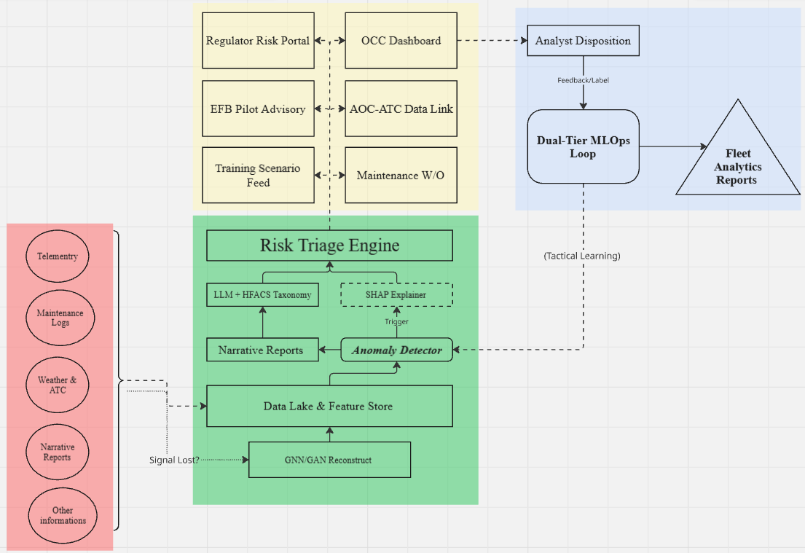

**Fig.1.** AI-HFACS safety pipeline in real-time with closed-loop MLOps feedback (left); S-D-E-A-L loop (right)

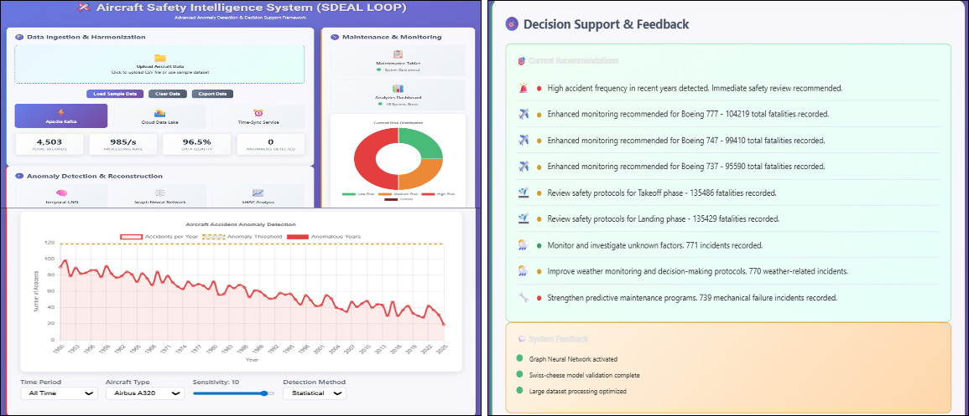

**Fig.2.** Aircraft Safety Intelligence System using SDEAL Loop

**Table 2:** Comparison between Traditional Methods and the SDEAL Loop

|  |  |  |
| --- | --- | --- |
| **Term** | **Traditional process** | **SDEAL Loop** |
| Precursor detection | After the event occurs | Less than one minute from the first abnormal sensor signal |
| Root cause investigation | Two to six months of data gathering and interviews | AI has already collected related information  Accident report processed/published |
| Corrective action | Slow AD/SB release, reactive maintenance | Auto-generated work order (if required) |
| Learning from errors | Paper reports, theory | Automatic update, continuous learning |

## 6. Case Study

The purpose is to examine the details of the difference between the traditional workflow and using a model that is integrated with AI.

|  |  |  |
| --- | --- | --- |
| **Aspect** | **Manual Workflow** | **SDEAL and MLOps Pipeline** |
| Data intake latency | ADS-B & ATC tapes pulled hours–days after crash; analyses start when investigators arrive | Live ADS-B, ATC audio, CVR streams, and weather feeds flow to Data Lake in real-time. |
| Anomaly detection trigger | Investigators infer runway incursion by replaying tapes frame-by-frame. | GNN detects dual occupancy of runway-ID 34R → flag within seconds. |
| Explainability of root causes | Requires manual construction of event chain; limited quantification of causal weight. | SHAP explainer assigns 42 % risk to the “ATC-clearance-lag” feature. |
| Actionable outputs | Safety bulletin issued weeks later; runway-status-light study proposed.  Process open to human bias. | Regulator Portal auto-issues recommendation; EFB advisory pushes go-around SOP same day. |
| Feedback/learning loop | Findings incorporated into training manuals months later. | Analyst labels feed Dual-Tier MLOps → model retrained nightly; clearance-lag feature weight updated. |
| Training & simulation | Simulator scenarios were written ad-hoc after the interim report. | Training Scenario Feed auto-generates VR incursion drill within 24 hour. |

## 8. Conclusion

## References

Baldissone (2019) Occupational accident-precursors data collection and analysis according to Human Factors Analysis and Classification System (HFACS) taxonomy. *Data in Brief* 26. doi: 10.1016/j.dib.2019.104479.

IATA (2024) *2024 Full Year Accident Update*.

Nanduri, A. and Sherry, L. (2016) Anomaly detection in aircraft data using Recurrent Neural Networks (RNN). *ICNS 2016: Securing an Integrated CNS System to Meet Future Challenges* pp. 5C2-1-5C2-8. doi: 10.1109/ICNSURV.2016.7486356.

Wang, F (2025) A Deep-Learning Method for Remaining Useful Life Prediction of Power Machinery via Dual-Attention Mechanism. *Sensors* 25(2), pp. 1–19. doi: 10.3390/s25020497.

Ziakkas, D. and Pechlivanis, K (2023) Artificial intelligence applications in aviation accident classification: A preliminary exploratory study. *Decision Analytics Journal* 9(November), p. 100358. doi: 10.1016/j.dajour.2023.100358.